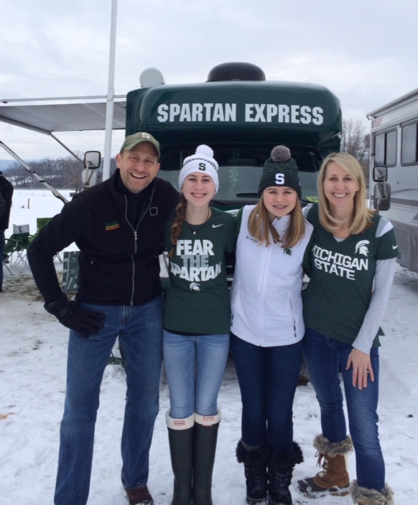
Happy New Year! I hope you all enjoyed the holidays with your families last month.
It's hard to believe that we are now into 2015 and the second semester of school has begun. My wish for you all this year is that you make every day count. Along with our busy schedules, I hope we find a quiet time each day where we can reflect on our blessings , cherish all the good in our lives, and celebrate our successes (and not be so hard on ourselves). Not everyone is as fortunate, and I hope we are reminded of NCL's mission and extend ourselves to those who need our support. Even the little things we do can mean so much to someone, so don't ever under-estimate the power we have to make a difference.
There are many opportunities to serve those in our community over the next several months. We kicked off the year with our first joint military initiative on January 11th. Several of the Atlanta NCL chapters came together to assemble packages for our troops and heard 2 dynamic speakers, including Remmington Youngblood, a local eighth grader, who founded our newest philanthropy Change 4 Georgia. Later this month on January 31st, all our chapter's TTs will participate in Ticktocker Day. On this day, we have Revved Up Kids coming to speak to the girls about self defense and then they will be involved in several philanthropic activities that will benefit CURE and Jesse's House. These are two fantastic opportunities that allow the girls to serve along-side their peers and get to know one another better while helping others.
In March, we look forward to recognizing the senior girls and their accomplishments while they have been involved in NCL at our annual Senior Presents. This is a very special occasion and I look forward to this wonderful event on March 7th at the Country Club of Roswell. More information and tickets will become available soon so stay tuned...
Before you know it we will be welcoming our new members, attending the Mother -Daughter Tea and Awards, and ending our year at the CURE Family Picnic. These are just a few highlights, but there are many other activities planned with your grade level and posted on the calendar - get involved and make the "NCL Experience" the best it can be! Remember to "Lead, Serve, Grow" in all you do in 2015.
All my best to you in the new year.
Christy Pincheon
President

